Huan Shiuan Huang

Assignment 1

CMSCS 204

9/15/2020

**UML**

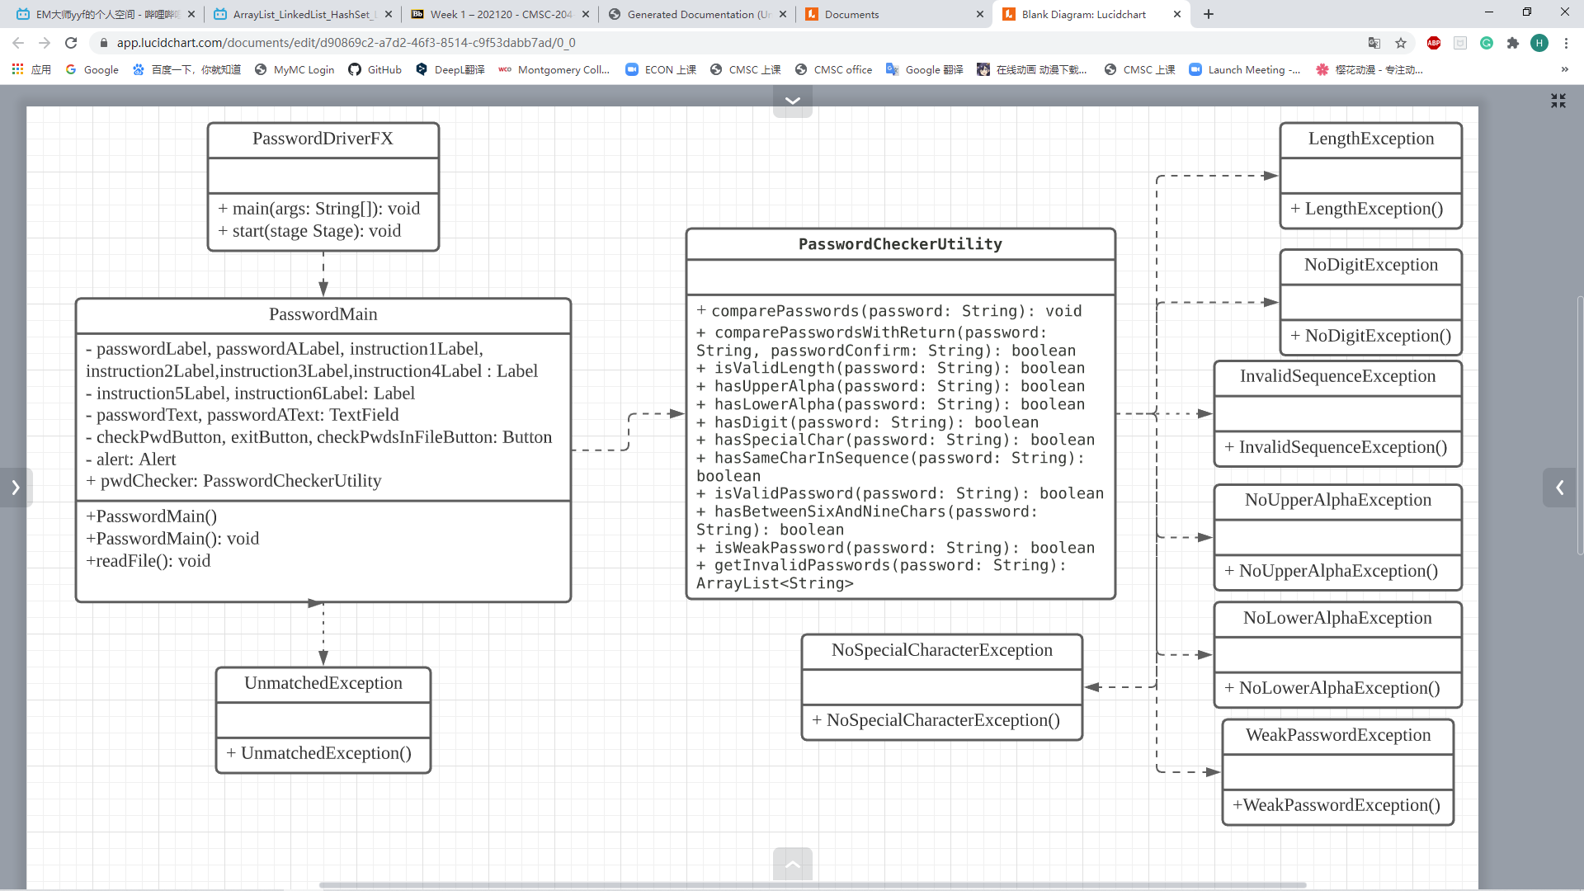

**test table**

|  |  |  |  |  |  |
| --- | --- | --- | --- | --- | --- |
| **Test Case #** | **Input** | **Actual Input** | **Expected Output** | **Actual Output** | **Did the test pass?** |
| 1 | AABBcc | AABBcc | The password must contain at least one digit | The password must contain at least one digit | Yes |
| 2 | AAAbb123 | AAAbb123 | The password cannot contain more than two of the same character in sequence. | The password cannot contain more than two of the same character in sequence. | Yes |
| 3 | AAbbCC123# | AAbbCC123# | Password is valid | Password is valid | Yes |

**Github**

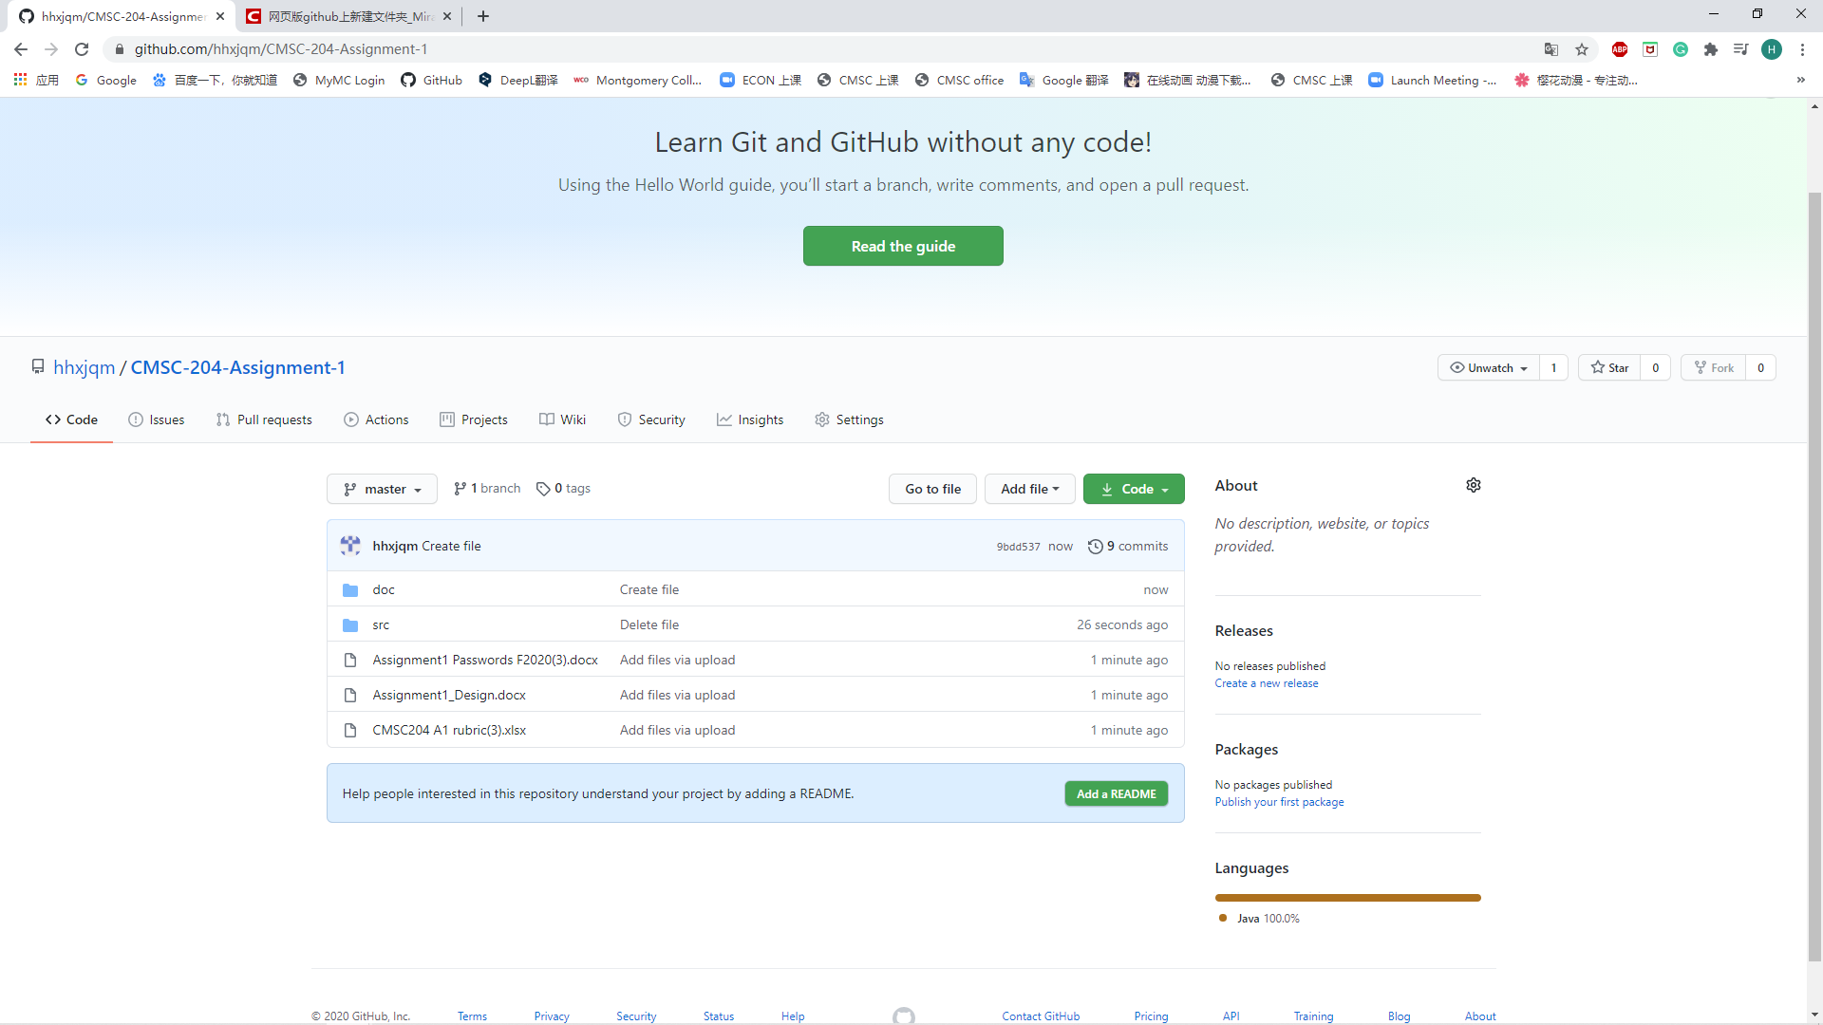

**Learning Experience**

What I learned from this project is that review what I learn in the CMSC 203, such as exception and Junit.

What I struggle with is that the assignment usually make mistake. This case me need to meet professor many times.

I will make my code look cleaner in next project. I think I did the all part successful.